A Novel Approach For Face Recognition Using
Discriminative Approach And Local Binary Pattern

P.Karthigayani¹ and Dr.S.Sridhar²
¹ Research Scholar, Sathyabama University ²Director(R&D), SKR Engg.College, Chennai
sureshkarthi2008@gmail.com¹, drssridhar@yahoo.com²

Abstract –
Estimating human age automatically via facial image analysis has lots of potential real-world applications, such as human computer interaction and multimedia communication. However, it is still a challenging problem for the existing computer vision systems to automatically and effectively estimate human ages. In this research project, we study the problem by designing and evaluating discriminative approaches. First, we find that the gradient orientation (GO), after discarding magnitude information, provides a simple but effective representation for this problem. When combined with a support vector machine (SVM). Our experiments are conducted on the Morph dataset and two large passport datasets, one of them being the largest ever reported for recognition tasks. Second, taking advantage of these datasets, we empirically study how age gaps and related issues (including image quality, spectacles, and facial hair) affect recognition algorithms. We found surprisingly that the added difficulty of verification produced by age gaps becomes saturated after the gap is larger than four years, for gaps of up to ten years. The face boundary can be differ from different age groups. Identify the age groups of a human based on the edges and stored in the database. Compare the input image and the existing database image. The input will be coming from any sensor devices like camera, robotics, GPS (global positioning system). Discriminative methods defines the input image appears in which clusters in the pattern space.

Key words: GOP,Morph dataset, Discriminative approach, Image processing, LBP pattern, Age progression and Age estimation

1. Introduction
Age-progression is the process of modifying a face image in order to predict the future facial appearance of the corresponding person. Age progression in human faces has been addressed from two perspectives: (1) Towards automatic age estimation and age based classification from face images; (2) Towards computer-assisted age progression systems that could reliably predict one’s appearance across age. Age progression involves the modification of the shape and texture of a person’s face in order to reflect cross-population age-related trends (i.e., changes in face shape and introduction of wrinkles), coupled with person-specific transformations. The main issue in this subject is the accurate prediction of the facial appearance of a person along the time.
In verification, we must determine whether two images come from the same person, as opposed to recognition, in which an individual is identified from a large gallery of individuals. An advantage of this problem is that it does not require many images for each subject, which is often difficult for collections across aging. This problem directly relates to the passport renewal task that is important for the passport datasets in our experiments. In the task, a newly submitted photo needs to be compared with an old one, to ensure that the request is valid.

II. Analysis
2.1 Existing system: (literature survey)
In the existing research work is used to find the face verification and age progression of the image using GOP and discriminative method using FG-NET database. It is not easy to find the unauthorized persons (criminals) in the passport terminals, airports and in the public place. The images were retrieved from the passport database of different subjects such as illumination, facial expression etc are uncontrolled in this dataset.

Advantages :

- GOP demonstrates excellent performance for face verification with age gaps.
- The FGnet dataset, we observed that the image quality and presence of eye glasses bring more challenges than facial hair.

Disadvantages:
- We found surprisingly that the added difficulty of verification produced by age gaps becomes saturated when the age gap is larger.

2.2 Proposed system:

In the proposed research work is used to find the face verification and age progression of the image using GOP and discriminative method using MORPH database. The proposed method is to find the gradient orientation, after discarding magnitude information and collect the all orientations and form the gradient orientation pyramid. Our proposed method uses the Back Propagation Network. The proposed method is to identify how the age gaps and the related issues like image quality, spectacles and facial hair affect the existing system.

2.3 Functional requirements:

- Identifying external features

- Face Boundary Estimation

- Gradient Orientation and Gradient Orientation Pyramid

- Age Progression using Back Propagation Network

2.3.1 Identifying external features:

The datasets used in the method are, passport datasets and morph dataset. The several sources used in face verification are facial textures (wrinkles in the forehead), facial hair (mustache and beard), presence of glasses, scars etc. The second source is the change in image acquisition conditions, image quality change, image converted from non-digital photos, additional artifacts appeared due to some scanning process.

When the input data to is too large to be processed and it is suspected to be notoriously redundant (much data, but not much information) then the input data will be transformed into a reduced representation set of features (also named features vector). Transforming the input data into the set of features is called feature extraction. If the features extracted are carefully chosen it is expected that the features set will extract the relevant information from the input data in order to perform the desired task using this reduced representation instead of the full size input. Feature extraction involves simplifying the amount of resources required to describe a large set of data accurately. When performing analysis of complex data one of the major problems stems from the number of variables involved. Analysis with a large number of variables generally requires a large amount of memory and computation power which overfits the training sample and generalizes poorly to new samples. Feature extraction is a general term for methods of constructing combinations of the variables to get around these problems while still describing the data with sufficient accuracy.

2.3.2 Face boundary estimation:

The image can be extracted from the sensor device and placed in the stable space. The noises can be identified in the extracted image and suitable filters can be applied to detect the original image. To identify the morph dataset and calculate the edge of the morphed images, when the input is taken from the sensor device first the edge will be calculated and it can be compared from the static information.

The edge can be calculated after converting the original image into the binary scale image. The face boundary can be differ from different age groups. Compare the input image and the existing database image. To analyze the image that can be fall on which age group. Morphing describes the action taking place when one image (in this case a digital image) gets transformed into another or, in a more technical way, Morphing describes the combination of generalized image warping with cross-dissolve between image elements.

The advantage of this problem is that it does not require many images for each subject, which is often difficult for collections across aging. Furthermore, this problem directly relates to the passport renewal task that is important for the passport datasets in our experiments. In the task, a newly submitted photo needs to be compared with an old one, to ensure that the request is valid.

2.3.3 Face verification and age progression using Discriminative method and GOP (Gradient Orientation Pyramid)

Gradient Orientation and Gradient Orientation Pyramid:

We find that the gradient orientation (GO), after discarding magnitude information, provides a simple but effective representation for this problem. This representation is further improved when hierarchical information is used, which results in the use of the gradient orientation pyramid (GOP). Image pair is considered as p(I1,I2). Given an image form the gradient orientation pyramid from the interval zero to n times. When the interval increases then the resolution is decreases. The noises will be occurred more at the final stage in the pyramid. The filters are used to tune the image in the original format then create the feature vector for the essential format using the image pairs. GOP demonstrates excellent performance for face verification with age gaps. This is mainly motivated by the illumination insensitivity of gradient orientation. The pyramid technique is used to capture hierarchical information that further improves the representation. Then, given a face image pair, we use the cosines between gradient orientations at all scales to build the feature vector.

2.3.4 Age Progression using Back Propagation Network:

Back Propagation Algorithm:
The following steps summarize the back propagation algorithm:
- Propagate the input forward through the network to the output.
- Propagate the partial derivatives of the error function backward through the network.
- Update the weights and biases of the network.
- Repeat until stop condition is reached.

In the case the inputs are not fully connected as usually assumed by the algorithms. The weights corresponding to missing connections can be simply ignored in the updating step, and when included in the calculation of the error they can be considered of zero value.
If the weight values are too large the net value will large as well; this causes the derivative of the activation function to work in the saturation region and the weight changes to be near zero. For small initial weights the changes will also be very small, which causes the learning process to be very slow and might even prevent convergence.

2.4 Network layers:

The commonest type of artificial neural network consists of three groups, or layers, of units: a layer of "input" units is connected to a layer of "hidden" units, which is connected to a layer of "output" units.
The activity of the input units represents the raw information that is fed into the network.
The activity of each hidden unit is determined by the activities of the input units and the weights on the connections between the input and the hidden units.
The behaviour of the output units depends on the activity of the hidden units and the weights between the hidden and output units.

i1
i2
h4
h3
h2
h1
op
INPUTS
HIDDEN
LAYER
OUTPUT

Figure 2.3.4 Artificial Neural Networks

This simple type of network is interesting because the hidden units are free to construct their own representations of the input. The weights between the input and hidden units determine when each hidden unit is active, and so by modifying these weights, a hidden unit can choose what it represents.
We also distinguish single-layer and multi-layer architectures. The single-layer organisation, in which all units are connected to one another, constitutes the most general case and is of more potential computational power than hierarchically structured multi-layer organisations. In multi-layer networks, units are often numbered by layer, instead of following a global numbering.

III. Design
3.1 Data structures:

In machine-vision applications involving the human face are of major importance, since the face is the natural and most important interface used by humans. Many reasons lie behind the importance of the face as an interface. For starters, the face contains a set of features that uniquely identify each person more than any other part in the body. Basic applications involve face detection, face recognition and mood detection, and more advanced applications involve lip reading, basic temperature diagnoses, lye detection, etc. As the demand on more advanced and more robust applications increase, the conventional use of gray-scaled images in machine-vision applications in general, and specifically applications that involve the face is no longer sufficient. Colour information is becoming a must. It is surprising that until recent study demonstrated that colour information makes contribution and enhances robustness in age estimation.

3.2. Tables and Figures
Face Image Enhancement
Feature Extraction from the face image
Face Boundary Estimation
Gradient Orientation Pyramid

Back Propagation Neural Network
Store weight and Threshold values
Calculating the output
  - Training and Learning Functions

Training and learning functions are mathematical procedures used to automatically adjust the network's weights and biases. The training function dictates a global algorithm that affects all the weights and biases of a given network. The learning function can be applied to individual weights and biases within a network.
Neural Network Toolbox supports a variety of training algorithms, including several gradient descent methods, conjugate gradient methods, the Levenberg-Marquardt algorithm (LM), and the resilient backpropagation algorithm (Rprop). The toolbox’s modular framework lets you quickly develop custom training algorithms that can be integrated with built-in algorithms. While training your neural network, you can use error weights to define the relative importance of desired outputs, which can be prioritized in terms of sample, timestep (for time-series problems), output element, or any combination of these. You can access training algorithms from the command line or via a graphical tool that shows a diagram of the network being trained and provides network performance plots and status information to help you monitor the training process.

3.3 Preprocessing and Postprocessing Functions

Preprocessing the network inputs and targets improves the efficiency of neural network training. Postprocessing enables detailed analysis of network performance. Neural Network Toolbox provides preprocessing and postprocessing functions and Simulink blocks that enable you to: Reduce the dimensions of the input vectors using principal component analysisPerform regression analysis between the network response and the corresponding targets Scale inputs and targets so that they fall in the range [-1,1] Normalize the mean and standard deviation of the training set Use automated data preprocessing and data division when creating your networks

  - Improving Generalization:

Improving the network’s ability to generalize helps prevent overfitting, a common problem in neural network design. Overfitting occurs when a network has memorized the training set but has not learned to generalize to new inputs. Overfitting produces a relatively small error on the training set but a much larger error when new data is presented to the network. Neural Network Toolbox provides two solutions to improve generalization: Regularization modifies the network’s performance function (the measure of error that the training process minimizes). By including the sizes of the weights and biases, regularization produces a network that performs well with the training data and exhibits smoother behavior when presented with new data.
Early stopping uses two different data sets: the training set, to update the weights and biases, and the validation set, to stop training when the network begins to overfit the data.

3.5 A sample testing cycle
Although testing varies between organizations, there is a cycle to testing:
- Requirements Analysis: Testing should begin in the requirements phase of the software development life cycle. During the design phase, testers work with developers in determining what aspects of a design are testable and under what parameter those tests work.
- Test Planning: Test Strategy, Test Plan(s), Test Bed creation.
- Test Development: Test Procedures, Test Scenarios, Test Cases, Test Scripts to use in testing software.
- Test Execution: Testers execute the software based on the plans and tests and report any errors found to the development team.
- Test Reporting: Once testing is completed, testers generate metrics and make final reports on their test effort and whether or not the software tested is ready for release.
Not all errors or defects reported must be fixed by a software development team. Some may be caused by errors in configuring the test software to match the development or production environment. Some defects can be handled by a workaround in the production environment. Others might be deferred to future releases of the software, or the deficiency might be accepted by the business user. There are yet other defects that may be rejected by the development team (of course, with due reason) if they deem it inappropriate to be called a defect.
IV. System Implementation
System implementation is the final phase of putting the utility into action. Implementation includes the final testing of the complete system to user satisfaction, and supervision of the initial of the new system.

Age progression involves the modification of the shape and texture of a person’s face in order to reflect cross-population age-related trends (i.e., changes in face shape and introduction of wrinkles), coupled with person-specific transformations. The main issue in this subject is the accurate prediction of the facial appearance of a person along the time .

The ability to produce accurate age-progressed images is important in several applications including the localization of missing people, the development of age invariant face recognition systems, and automatic update of photographs appearing in smart documents (i.e., smart id cards).

Test Data Set:
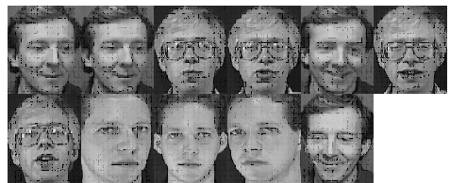

Trained Data Set:
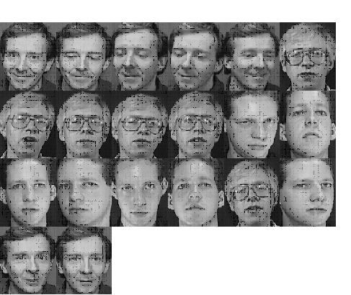
V. Conclusions & Future Enhancement
The effect of the aging process on verification algorithms is done empirically. In the experiments we observed that the difficulty of face verification algorithms saturated when the age gap is larger. We also implemented the effects of age related issues including image quality, and facial hair. We use the Gradient Orientation Pyramid in order to discard the magnitude information and we have used the Back propagation network (BPN) method to find the exact age of a person.
A face image is considered as a combination of many small blocks and local binary pattern histograms are extracted from them as features used for face recognition. Different from the traditional method, we use edge map substitute the gray image to extract local binary pattern. A face image per person was used for training while five other images per person were used for testing. Depending on the Euclidean distance, 100% recognition rate was achieved for images tested. For verification, 80% correct classification (Hit) occurred while 20% were misclassified. The rest of the images that were not in the training set were used to test the false acceptance rate (FAR) i.e. the ratio of the numbers of images falsely accepted to the total number of images tested and 0.02 FAR occurred.
First of all, testing on a large public dataset will be conducted for deeper understanding of the proposed approaches. We plan to work on the MORPH dataset for this purpose. Second, we plan to apply other discriminative approaches (e.g.,boosting) for simultaneous feature analysis and classification. We plan to work on the MORPH dataset for this purpose. Second, we plan to apply other discriminative approaches (e.g.,boosting) for simultaneous feature analysis and classification.
Appendix
A.Screen shots
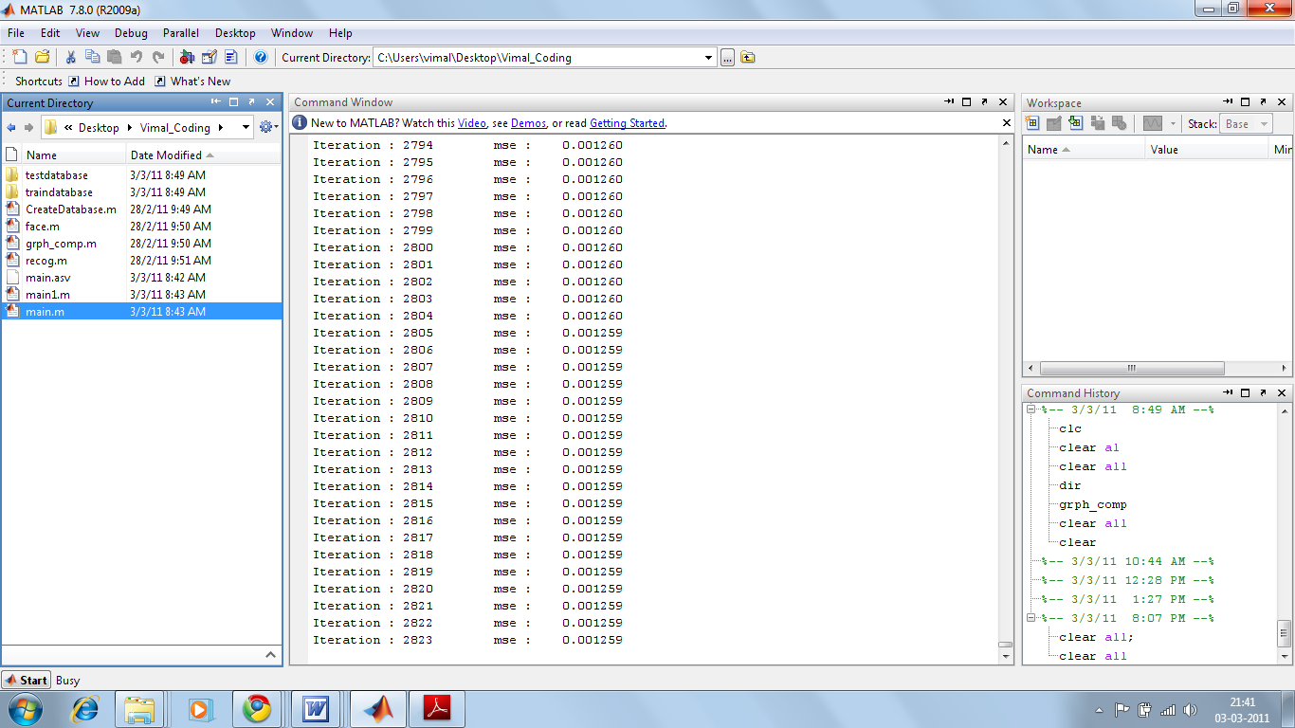
Figure 1: Loading trained images
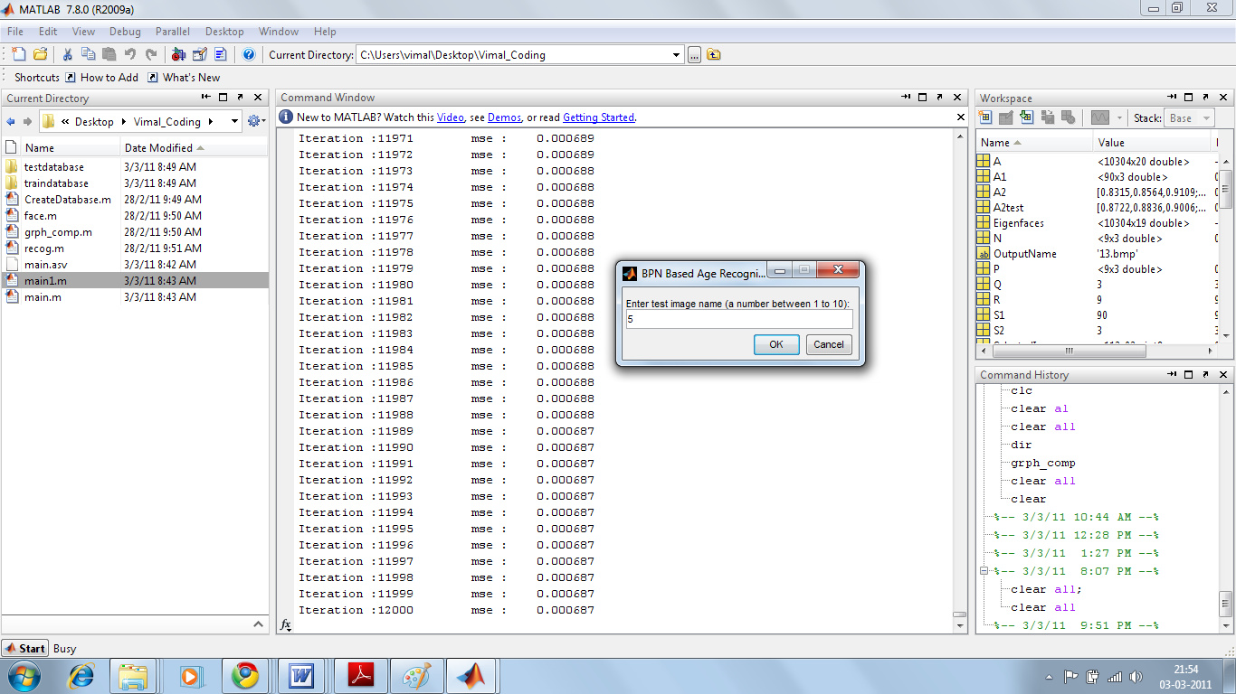
Figure 2: Loading test images
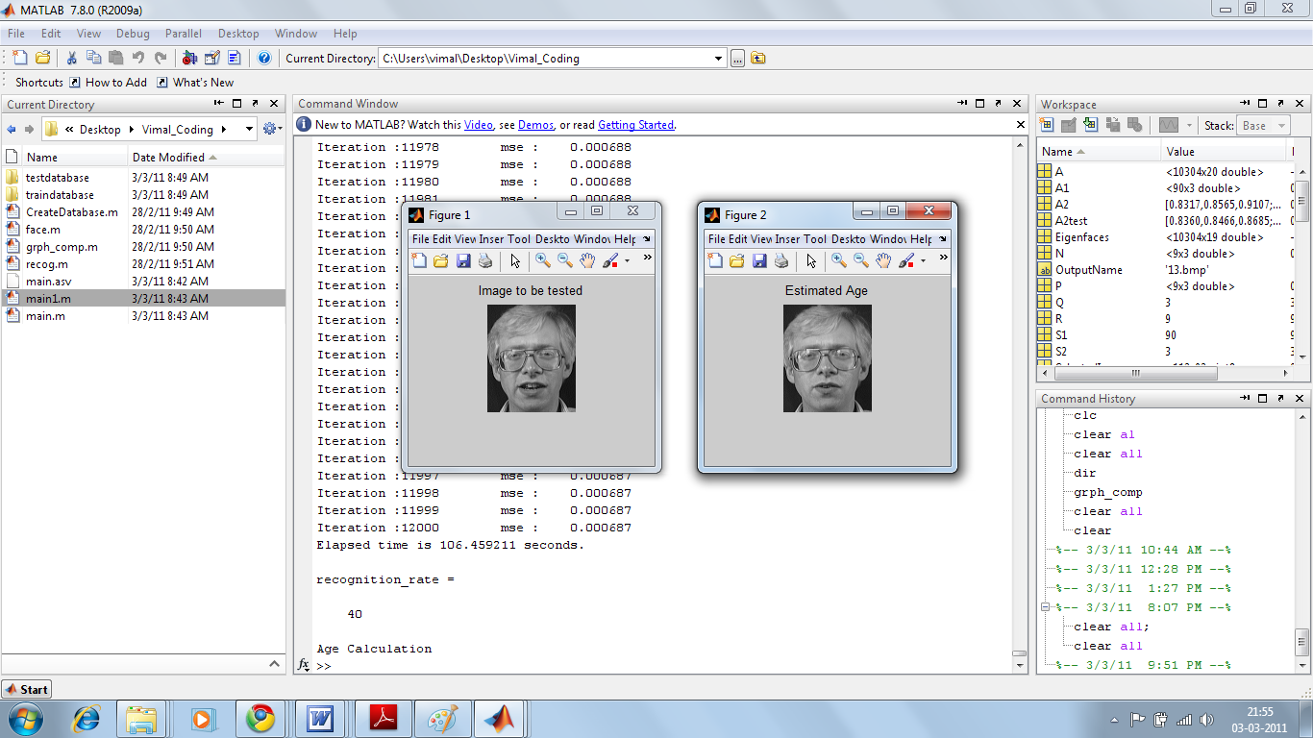

Figure 3: Estimating the age 1
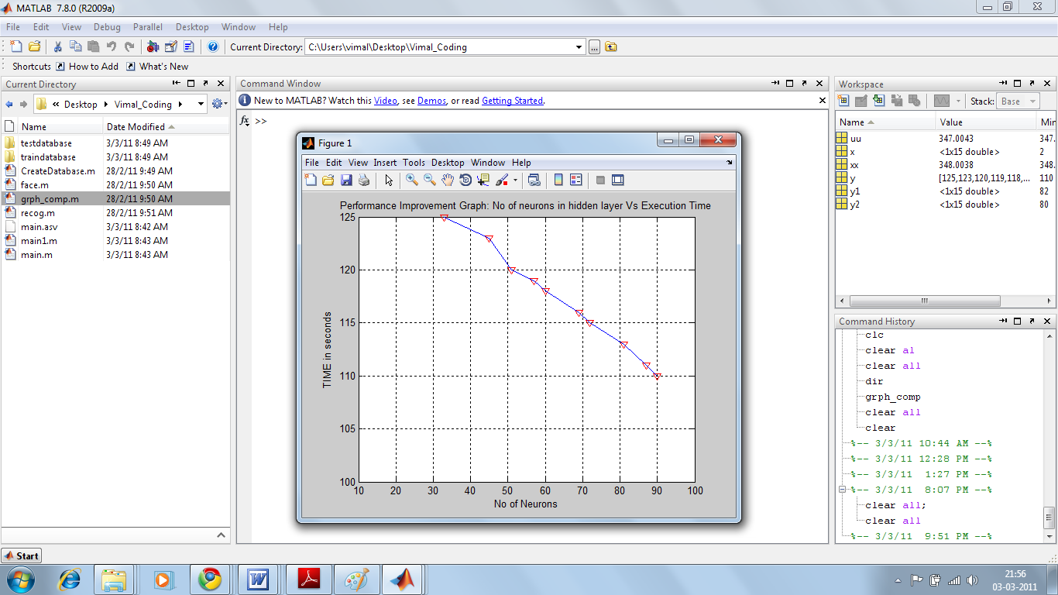
Figure 4: Performance improvement graph 1
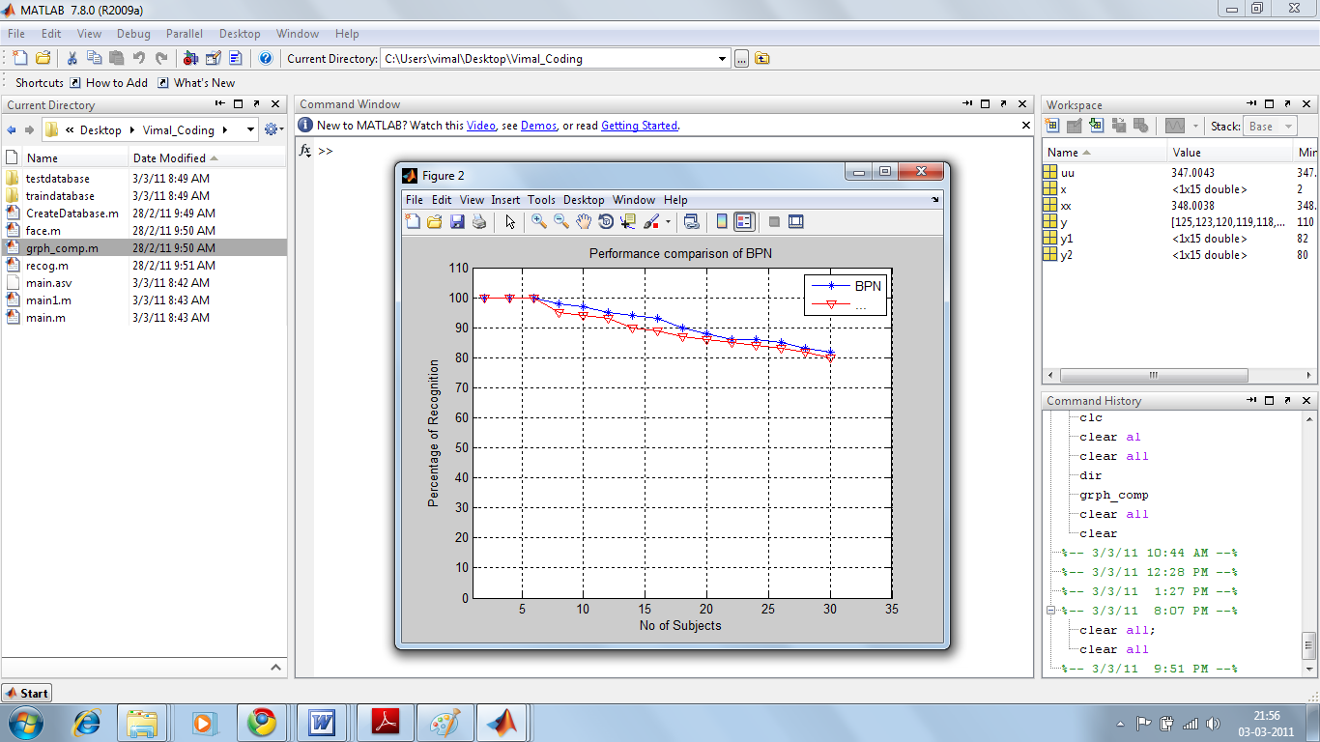
Figure 5: Performance comparison of BPN 1
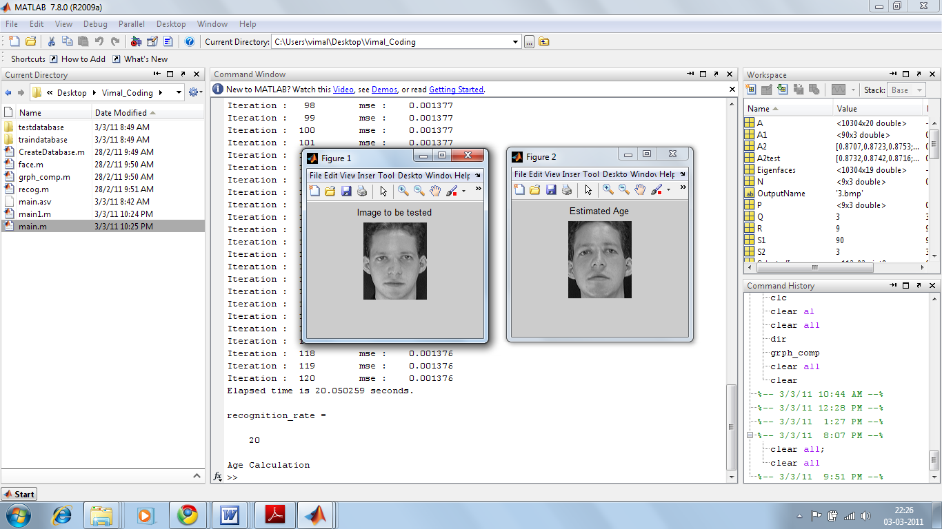
Figure 7: Estimating the age 2
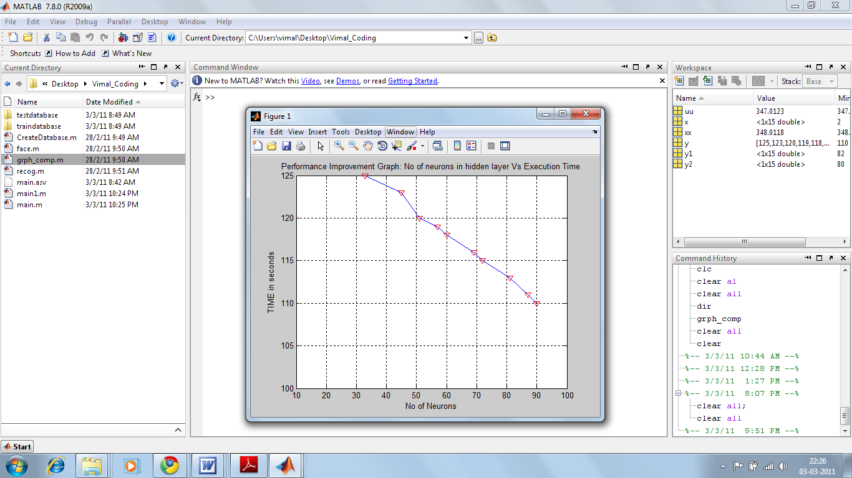

Figure 8: Performance improvement graph 2
Result: Face verification using passport Dataset using BPN method
age gap | Error rate
1-4 | 0.15
4-7 | 0.17
7-10 | 0.15
10-15 | 0.16
15-20 | 0.17
20-40 | 0.02

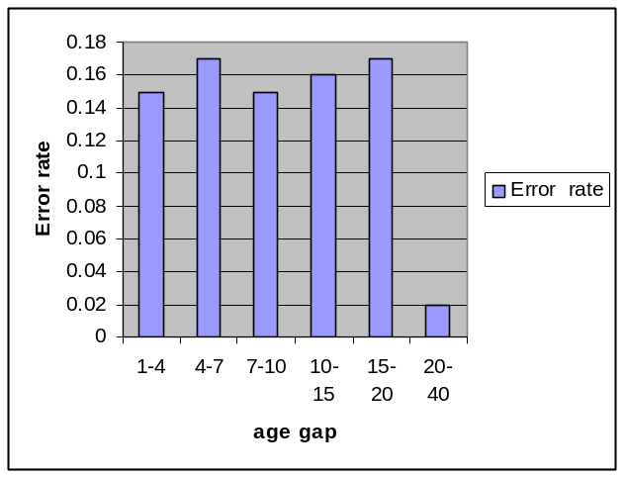

Existing Result: Face Verification using Passport Dataset using Bayesian Method

age Gap | Error rate
1-4 | 0.15
4-7 | 0.17
7-10 | 0.15
10-15 | 0.13
15-20 | 0.11
20-40 | 0.05

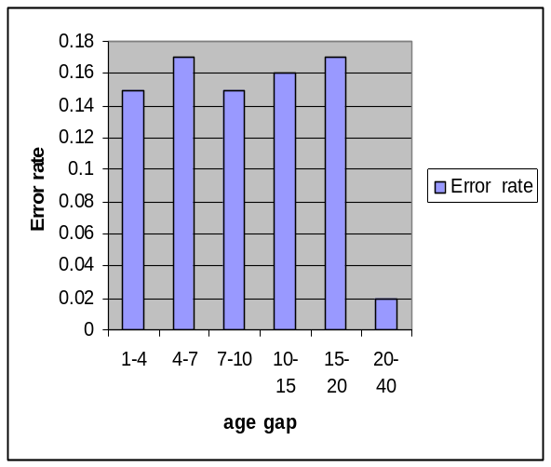

6. References

i. N. Ramanathan and R. Chellappa, “Face verification across age progression,”IEEE Transactions on Image Processing, vol. 15, no. 11, pp.3349–3361, 2006.
Ii “Modeling age progression in young faces,” in IEEE Conference on Computer Vision and Pattern Recognition (CVPR), vol. 1, 2006, pp. 387–394.
iii. X. Geng, Z.-H. Zhou, and K. Smith-Miles, “Automatic age estimationbased on facial aging patterns,” IEEE Trans. Pattern Anal. Mach. Intell., vol. 29, no. 12, pp. 2234–2240, 2007
iv.M. Turk, A. Pentland (1991). “Eigenfaces for recognition”. Journal of Cognitive Neuroscience. Vol.3, No.1, pp.71-86.
v. MS Bartlett, JR Movellan, TJ Sejnowski (2002). “Face recognition by independent component analysis”. IEEE Trans. on Neural Networks. Vol.13, No.6, pp.1450-1464.
vi. Ahonen, A. Hadid, and M. Pietikainen (2004). "Face
Recognition with Local Binary Patterns", ECCV. pp.469
vii.Automatic Age Estimation Based on Facial Aging Patterns December 2007 (vol. 29 no. 12)
pp. 2234-2240
Xin Geng Zhi-Hua Zhou, IEEE Kate Smith-Miles, IEEE DOI Bookmark: http://doi.ieeecomputersociety.org/10.1109/TPAMI.2007.70733
Viii Image-Based Human Age Estimation by Manifold Learning and Locally Adjusted Robust Regression
Guodong Guo Yun Fu Dyer, C.R. Huang, T.S.
Dept. of Comput. Sci., North Carolina Central Univ., Durham, NC Date of Publication: 2008
ix. Automated fish age estimation from otolith images using statistical learning Ronan Fablet and Nicolas Le Josse Ifremer/LASAA, BP 70, 29280 Plouzane, France Received 21 April 2004
X Expression-robust 3D face recognition using LBP representation Hengliang Tang; Yanfeng Sun; Baocai Yin; Yun Ge; Beijing Key Lab. of Multimedia & Intell. Software Technol., Beijing Univ. Of Technol., Beijing, China Issue Date: 19-23 July 2010
xi. LBP Discriminant Analysis for Face Verification
Authors: Jiali Zhao,Haitao Wang, Haibing Ren, Seok-Cheol Kee, Samsung Advanced Institute of Tech, Proceeding CVPR '05 Proceedings of the 2005 IEEE Computer Society Conference on Computer Vision and Pattern Recognition (CVPR'05) - Workshops - Volume 03

Xii.An efficient branch and bound method for face recognition
Utsumi, Y. Matsumoto, Y. Iwai, Y.
Grad. Sch. of Eng. Sci., Osaka Univ., Toyonaka, Japan Signal and Image Processing Applications (ICSIPA), 2009 IEEE International Conference on
18-19 Nov. 2009

Xiii. Research on Face Recognition Method based on Cognitive Mechanism
Jia Cui Jian-Ping Li Yu-Jie Hao
Dept. of Comput. Sci. & Eng., Univ. of Electron. Sci. & Technol. of China, Chengdu Apperceiving Computing and Intelligence Analysis, 2008. ICACIA 2008. International Conference on 13-15 Dec. 2008

): 62 - 65

